CREATE PROJECT STRUCTURE
First create this exact structure.

In Kali Linux Terminal

mkdir -p ~/cyart-red-teaming/Week\4

cd ~/cyart-red-teaming/Week\ 4

Now create folders:

mkdir Notes Screenshots Reports Logs Workflow Tools
Now create subfolders:
mkdir Screenshots/C2
mkdir Screenshots/Cloud
mkdir Screenshots/Caldera
mkdir Screenshots/Evasion
mkdir Screenshots/LOLBAS
mkdir Screenshots/Capstone

WHAT WE NEED
For this lab ideally:
Machine | Purpose
Kali Linux | Attacker
Windows VM | Target

Install Metasploit
sudo apt install metasploit-framework -y
msfconsole
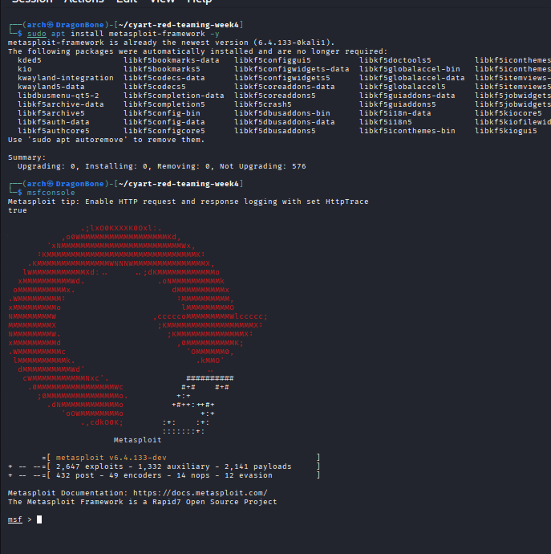

Install AWS CLI

sudo apt install awscli -y
aws --version

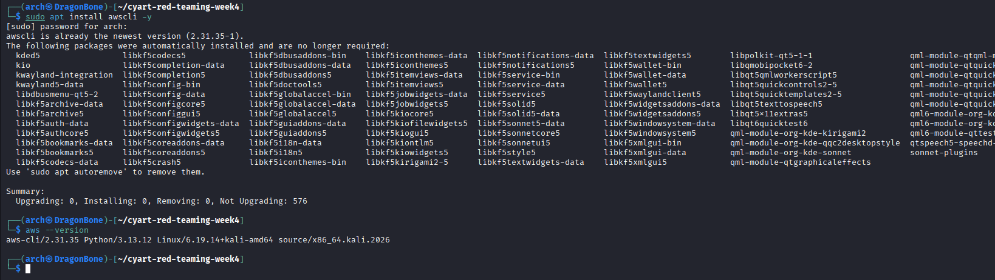

Install Proxychains

sudo apt install proxychains4 -y
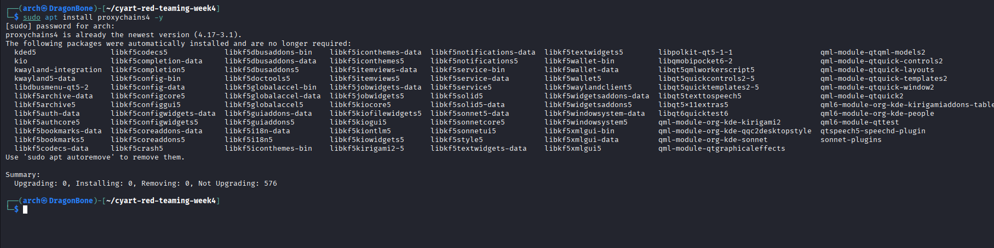

Install Veil

sudo apt install veil -y

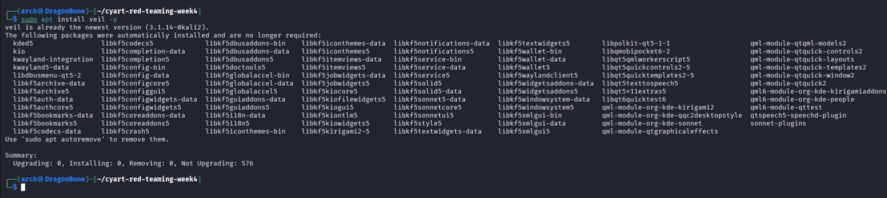

Install Wazuh Agent Tools

sudo apt install wazuh-agent -y

sudo apt install virtualbox -y
sudo apt install linux-headers-$(uname -r) -y
uname -r

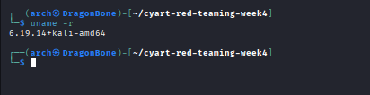

virtualbox

